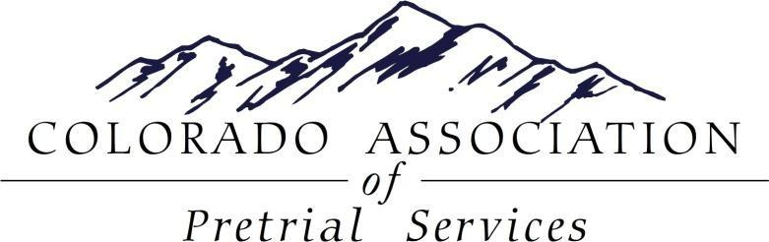

CAPS 2016 SPRING TRAINING

This year’s spring training will be a mirroring 4-hour session (morning and afternoon) with speakers from 3 different Colorado Jurisdictions presenting updates on where Bond/Pretrial is advancing in their respective Counties. CAPS is excited to welcome Mesa County’s Deputy District Attorney, Bo Zeerip, Denver County‘s Aubree Cote with the SMART Pretrial Grant, and Boulder County’s Research Data Analyst Alison Birchard. See below for a detailed description on each presentation as well as registration information. Please register early as space is limited.

DATE: Thursday, May, 19, 2016
Morning Session: 8:00-12:00pm (Registration and Continental Breakfast 7:30-8:00am)
Afternoon Session: 1:00pm-5:00pm (Registration 12:45-1:00pm)

LOCATION: Adams County Government Center-See detailed instructions below
4430 S. Adams County Parkway
Brighton, CO 80601

COST: Members: $20 per person
Non-members: $25 per person
Identical Morning and Afternoon Sessions offered for this training. A Continental Breakfast will be provided for the morning session and light snacks/refreshments will be provided for the afternoon session.

Bo Zeerip, DDA with Mesa County
Bo Zeerip is a Senior Trial Deputy District Attorney in the 21st Judicial District, in Mesa County, Colorado. His current duties include prosecuting the highest level felony cases, and training other District Attorneys and law enforcement officers. He also currently serves as the primary prosecutor for the Western Colorado Drug Task Force. Bo also currently serves as the District Attorney’s representative on the Mesa County Pretrial Bail/Bond Committee. Over the past few years he has collaborated with various criminal justice stakeholders in Mesa County to accomplish a major overhaul of pretrial and bond practices. He has also been an advocate for a workable preventative detention statute for the State of Colorado. Bo has presented to various state-wide groups and forums in the state of Colorado, as well as in the State of Washington, New Mexico, Delaware, and California. In 2015 he presented in Los Angeles, California at the Association of Prosecuting Attorneys Conference on Innovations where he received a national award on behalf of Mesa County for innovations in pretrial and bond practices. Bo is currently serving on the Pretrial Standards Committee revising the national recommendations and standards for pretrial / bail / bond for NAPSA (National Association of Pretrial Agencies) and NIC (National Corrections Institute).
CAPS is very excited to have Bo present on Pretrial/Bond in Mesa County and the strides they have made to have such a collaborative system in their jurisdiction. As told by his bio, Bo has a lot of knowledge to offer other Counties who are working towards the goals that Mesa has achieved as well as valuable insight as to what the future holds.
Aubree Cote, SMART Pretrial, Denver County
Aubree Cote is currently the Denver Site Coordinator for the Bureau of Justice Assistance Smart Pretrial Demonstration Initiative. Prior to this work, Ms. Cote was a supervisor with the Pretrial Services Unit of the City and County of Denver Division of Community Corrections, Department of Safety. For the last sixteen years, she has worked in the Community Corrections Division in Denver initially as an Electronic Monitoring Probation Officer, then moved to the position of Pretrial Supervision Unit Supervisor. Prior to working for the City and County of Denver, she worked in residential community corrections and alternative sentencing. She served as President of the Executive Board of the Colorado Association of Pretrial Services for four years. She is a National Association of Pretrial Services certified pretrial professional. Ms. Cote holds a bachelor’s degree in Sociology and a Masters in Criminal Justice from the University of Colorado.
Smart Pretrial Demonstration Initiative is the first federal pretrial demonstration project in over 30 years and continues momentum for improved front end justice processes at the national, state and local levels. In 2013, Denver was chosen as one of three sites to receive the Bureau of Justice Assistance grant and became an SPDI site. The other sites include the state of Delaware and Yakima County in Washington State. SPDI has provided an opportunity to capitalize on Denver’s current climate of legislative progress and risk driven decision making and examine pretrial system best practices at the local system level.
Denver has formed a multidisciplinary Smart Pretrial Policy Team with representation from the pretrial system stakeholders. This team has worked with technical assistance providers to map, measure, and assess the current pretrial justice processes and has developed an action plan based on the identified opportunities for improvement. Currently, Denver is in Phase Two of the three year grant, implementing identified system improvements while measuring their outcomes and planning for sustainability in Phase Three of the grant process. CAPS is enthusiastic to have Aubree present on the progress Denver is making with this initiative.
Alison Birchard, Research and Planning Analyst, Boulder County
Alison Birchard is the Research and Planning Analyst for Boulder County Community Justice Services. In this capacity, she facilitates the implementation of evidence-based practices and the measurement of outcomes. Alison has a Master's in Public Health from the University of Minnesota with a focus on Maternal and Child Health. Prior to working for Boulder County, she had a consulting business that focused on early childhood system-building at the state and local level.

CAPS is thrilled to welcome Alison as her presentation will show the link between the work pretrial professional s are doing with results that were predicted to be seen. Alison's presentation will summarize pretrial outcomes in the 20th Judicial District, with particular emphasis on the role of risk assessment, monetary and non-monetary bond types, and pretrial supervision.
REGISTRATION

 ONLINE REGISTRATION:

- Electronic payment is available via PayPal on the CAPS website at http://capscolorado.org under the Membership-Paypal link

- Please complete one registration form per attendee.

- Registration forms can be scanned and e-mailed to:

Allison Heemer, CAPS Treasurer and Mallory Starr, Secretary

Email: aheemer@douglas.co.us
mstarr@bouldercounty.org

MAIL IN REGISTRATION:

- Checks payable to: CAPS [Federal ID #: 20-2384017]

- Registration forms must arrive with payment to secure registration. Please complete one registration form per attendee.

- Mail registration form and payment to: Allison Heemer, CAPS Treasurer
CAPS PO Box 40591

Denver, CO 80204

REGISTRATION DEADLINE: May 13, 2016

********************************************************************************

CAPS Member: ☐ Non Member: ☐

Name:Click here to enter text.
Title/Agency:Click here to enter text.
Address:Click here to enter text.
City: Click here to enter text. State: Click here to enter text. Zip code:Click here to enter text.
Phone: Click here to enter text. Email: Click here to enter text.

DIRECTIONS AND PARKING
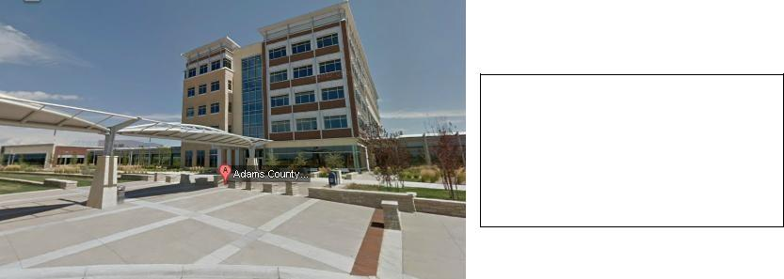

Adams County Government Center

4430 S. Adams County Pkwy

Brighton, CO 80601
The conference center parking and

building entrance are located on the

northwest side of the building.
